Barrowby Parish Council

Email: clerk@barrowbyparishcouncil.gov.uk
Address: Reading Room, Church Street, Barrowby, NG32 1BX
Website: https://barrowby.parish.lincolnshire.gov.uk

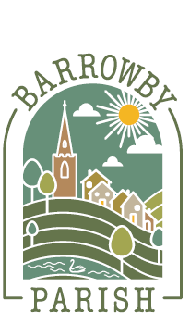
Title

Document control
- Owner: Full Council
- Responsible officer: Clerk / Proper Officer
- Adopted: [date] (Minute ref: [ ])
- Version: 2026.1
- Review: Annually or earlier if legislation/guidance changes
- Next review due: January-March 2027 at Full Council for formal adoption at Parish Council May 2027

