Barrowby Parish Council

Email: clerk@barrowbyparishcouncil.gov.uk
Address: Reading Room, Church Street, Barrowby, NG32 1BX
Website: https://barrowby.parish.lincolnshire.gov.uk

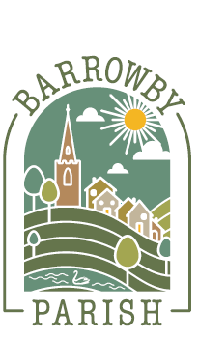
Data Consent Form

Barrowby Parish Council would like your permission to use your personal data for the specific optional purpose(s) ticked below.
Please read this form carefully. You do not have to give consent, and you may withdraw your consent at any time.
1. Your Details
Full Name | ______________________________________________
Address | ______________________________________________
 | ______________________________________________
Telephone Number | ______________________________________________
Email Address | ______________________________________________
2. What we are asking permission for
Please tick as appropriate.
[ ] To send me optional council news, updates and community information by email
[ ] To use my photograph in council publicity, including the website, social media and newsletters
[ ] To publish my name in connection with a community item, story, event or acknowledgement
[ ] Other specific consent purpose:
3. Important information
If you give consent:
- Barrowby Parish Council will only use your data for the purpose(s) you have agreed to above.
- You can withdraw your consent at any time by contacting the Assistant Clerk as the Council’s lead officer for data protection.
- Withdrawal will not affect processing already carried out before consent was withdrawn.
- Your data will be handled in accordance with the Council’s Privacy Notice.

4. Declaration
I consent to Barrowby Parish Council using my personal data for the purpose(s) ticked above.
Signature: ______________________ Date: __________________________
Print Name: __________________________
5. Parish Council Contact
For questions about this form or to withdraw consent, please contact the Assistant Clerk as the Council’s lead officer for data protection.
Barrowby Parish Council
Email: assistantclerk@barrowbyparishcouncil.gov.uk
Address: The Reading Room, Church Street, Barrowby Grantham, NG32 1BX
Phone: 07734967281
Document control
- Owner: Assistant Clerk
- Responsible officer: Clerk / Proper Officer
- Adopted: [ date] (Minute ref: [ ])
- Version: 2026.1
- Review: Annually or earlier if legislation/guidance changes
- Next review due: January-March 2027 at Full Council for formal adoption at Parish Council May 2027
Your Privacy Matters
Barrowby Parish Council is committed to protecting your personal data in accordance with the UK General Data Protection Regulation (UK GDPR). This form explains how we intend to use your information and requests your consent where appropriate.

