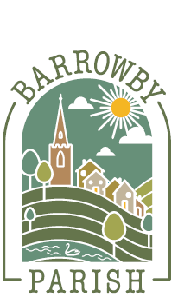
Barrowby Parish Council

Email: clerk@barrowbyparishcouncil.gov.uk
Address: Reading Room, Church Street, Barrowby, NG32 1BX
Website: https://barrowby.parish.lincolnshire.gov.uk

Application to Purchase the Exclusive Right of Burial in Barrowby Burial Ground
To be completed if purchasing a new plot

Barrowby Burial Ground is available to parish residents only, unless the Council resolves otherwise in exceptional circumstances. The Council may require proof of residence before confirming eligibility for burial, purchase of Exclusive Right of Burial, or the application of any fee category

 | Grantee 1 | Grantee 2 | Grantee 3
Full Name

Address
Time at the Address
Telephone
Email
Signature
Date

Resident Qualification |  | Address Check
Grant Number |  | Plot Number
Length of Term |  | Deed Issued
Invoice sent: |  | Payment received:
For Office use:
Document control
- Owner: Burial Ground Committee
- Responsible officer: Clerk / Proper Officer
- Adopted: [date] (Minute ref: [ ])
- Version: 2026.1
- Review: Annually or earlier if legislation/guidance changes
- Next review due: January-March 2027 at Burial Ground Committee meeting for formal adoption at Parish Council May 2027

